The 7 Stages Of Grieving
A Queensland Theatre Company and Grin and Tonic Theatre Troupe Production



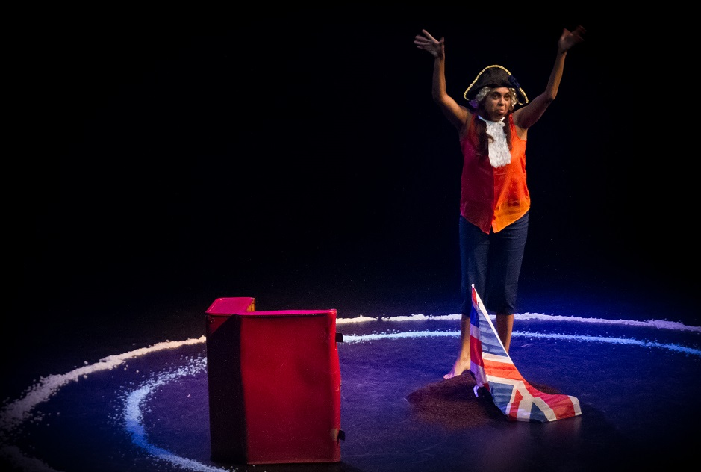
Chenoa Deemal – The 7 Stages Of Grieving Justin Harrison Photography

PRESENTER’S INFORMATION
Contents

COMPANY PROFILE 4
ABOUT THE SHOW 4
PERFORMANCE SPECIFICS 4
AUDIENCE ENGAGEMENT 5
MARKETING 5
PRODUCTION DETAILS 6
CONTACTS 8

COMPANY PROFILE
Queensland Theatre Company (QTC) is the state’s flagship professional theatre company.
Established in 1970, each year it creates new work and stages an eclectic mix of Australian and international productions. QTC is dedicated to encouraging artists and artform development through creative developments and extensive touring. Across 2015/16, QTC will deliver seven tours to regional and metropolitan audiences across Australia. Grin and Tonic’s Artistic Director, Jason Klarwein, has worked closely with QTC's esteemed Artistic Director Wesley Enoch and the rest of the team since 2014, as a QTC Resident Director. It is therefore, a natural progression that the two companies would establish a partnership to maximise opportunity to tour and present future performances of The 7 Stages of Grieving on national and international stages.

ABOUT THE SHOW

SHOW SYNPOSIS
Remaining a vital masterwork 20 years after it was penned by Wesley Enoch and Deborah Mailman, this new adaption of The 7 Stages of Grieving is a wise and powerful play about the grief of Aboriginal people and the hope of reconciliation.
In this one-everywoman show, Chenoa Deemal (QTC’s Mother Courage and Her Children) spins poignant stories of different people from different mobs – tear-streaked tales of tragedy go hand-in-hand with jubilant celebrations of simple survival. Funny, devastatingly sad, politically relevant and culturally profound as it traverses the phases of Aboriginal history, The 7 Stages of Grieving is an invitation to face hard truths, to join hands and grieve. It shares true and personal stories that need to keep being told.
And perhaps most importantly, it opens a dialogue about the issues that separate and unite Indigenous and non-Indigenous people.

ACKNOWLEDGEMENTS
Written by Wesley Enoch and Deborah Mailman

Directed by Jason Klarwein

Performed by Chenoa Deemal

Stage Manager Maddie Nixon

Set & Costume Design Jess Ross

Sound Design Justin Harrison

Lighting Design Daniel Anderson

BIOGRAPHIES
To be supplied

PERFORMANCE SPECIFICS

DURATION
55 minutes – no interval

SUITABLE VENUES
Pros Arch, flat floor – must have raked seating, and suitable rear wall or cyc for projection

MAXIMUM NUMBER OF PERFORMANCES PER WEEK
8 performances

MINIMUM BREAK BETWEEN PERFORMANCES
120 minutes

LICENCING AGREEMENTS
N/A

APRA OBLIGATIONS
.75% of Gross Box Office + GST (equates to 15% of show content)

TOURING PERSONNEL
The touring party consists of 3 people.
List the touring personnel below.
Name | Role
Chenoa Deemal | Performer
Kellie Lazarus | Stage/Tour Manager
TBC | Mech

PERFORMANCE HISTORY
Provide the performance history in the table below.
Year | Venue | Number of performances
2015 | Bille Brown Studio QTC | 17

AUDIENCE ENGAGEMENT

OVERVIEW
As listed on Artour show profile

DESCRIPTION / DETAILS
Full detail to come

COST
Free of Charge

TARGET AUDIENCE FOR COMMUNITY ENGAGEMENT
As listed on Artour show profile

MARKETING

MARKETING COPY
One line
To be supplied (10 words)

Short
To be supplied (100 words)

Extended
To be supplied (300 words)

MARKETING SUMMARY

MEDIA QUOTES
“… from any perspective this is a vital, throbbing piece of theatre in anybody’s cultural terms, and Chenoa Deemal’s performance is deadly.” “The text is flawless, the actor close to perfection, but what brings this play into the 21st century after 20 years, and redeems it from being just a period piece, is the direction and the staging.”
-Crikey ★★★★★
"Ten seconds into Jason Klarwein’s magnificent new production of The 7 Stages of Grieving, and you’re hooked by the sense of history.” “Humble, decent and engaging, Deemal is the personification of the play’s inclusive message: that what drives superficial anger is, in reality, an enduring sense of grief."
-The Australian

AUDIENCE REVIEWS
http://www.queenslandtheatre.com.au/Touring/Ready-to-Tour/The-7-Stages-of-Grieving Video 2 : vox pops

COLLEAGUE RECOMMENDATIONS
Ross Cunningham, Director – Presenter Services, QPAC

VIDEO LINKS
Please refer to artour profile or http://www.queenslandtheatre.com.au/Touring/Ready-to-Tour/The-7-Stages-of-Grieving

IMAGES
Please refer to artour show profile. Approx 10 high resolution production images will be available for download.

MARKETING MATERIALS
As per artour show profile.
Generic marketing material, developed specifically for the tour by QTC, will be developed ( and printed if required) on a user pays basis.

CONTENT WARNINGS / AUDIENCES TO AVOID
Year 9 – 12 Adult concepts (death, grief, race and discrimination)

SPONSOR OR OTHER ACKNOWLEDGEMENTS
N/A

TEACHER’S RESOURCES
Yes – will be available electronically

PRODUCTION DETAILS

TECHNICAL SUMMARY

EXAMPLE SCHEDULE
Bumpin 4 hours – 1st performance early afternoon matinee same day
Bumpout 2 hours
Other scheduling will be provided once itinerary built

CREW REQUIRED FROM VENUE
4 crew pre-rig lx approx. 4 hrs
2 x Multi skilled crew 8 hours Bump In
2 x Multi skilled crew 3 hours bump out

1 x LX (board op)

STAGE

Ideal Stage Dimension: 10m wide x 10m deep
Ideal Height: 5m
Please call to discuss if any queries

Non-raked floor surface with no uneven areas painted matte or low gloss black. A back wall or cyc suitable for front projection.

Set is designed to fit within a proscenium or black box style theatre. It is best if the audience can look down on the action as the set is concentric circles.

In the first scene a circle of glowing stones appears in the dark therefore a TOTAL black will be required for 90 seconds

[Company] to supply
all scenic and prop items

Venue to supply
2 x props tables

LIGHTING
Full details of a potential touring rig are still being developed. All equipment will be in current test and tag.

The lighting must be pre-rigged, patched, coloured and flashed out prior to company arrival.

[Company] to supply
Lighting Plan in relation to the venue.

Lighting Control:
· ETC ion lighting console (if producers console available)

5 x ROBE Robin (or similar movers).

Venue to supply
18 x 1200w fresnels
12 x 1000w profiles (25 – 50°)
16 x 1000w profiles (12 – 30°)

Lighting Control:
· ETC ion lighting console (may come with producer)

Lighting Effects:
· 2 x Gobo rotators with glass gobos.

Consumables:
· Black Wrap
· Electrical tape, gaff etc.

· Gel as per lighting plan

SOUND
The sound design utilises a surround sound system.

[Company] to supply
1 x Macbook Tower running Q-Lab3

Venue to supply
- 1 x 8-Channel (minimum) Sound interface (Focusrite Saffire or similar)
- Professional quality, full range sound system including but not limited to
- 2 x FOH speakers (left and right)
- 2 x subs (FOH left and right)
- 2 x Mid-Surround Speakers (rigged above the front row audience)
- 2 x Surround speakers (rigged in rear of the house left and right)
- capable of producing 85dBC per channel of clean, undistorted sound at 1m
- audio console
- minimum 8 channel
- 8 x outputs (L/R and separate Surround Masters if possible)
- per-channel routing/sends to Sub/LFE
· all appropriate patching, cabling, isolated power and drivers

NB - stereo sub send not required So it's two front, two middle, and two rear channels, and a mono sub send. That's 7. But 8 channels is required as the extra will be used.

A minimum of 5 speakers to ensure surround sound is good.

AV
[Company] to supply
2 x Projectors (min 720p capability) rigged above the audience. The projectors will be lensed and positioned so the joint image fills the entire rear wall (full PS to OP coverage), or as near to as possible.

Venue to supply
Projection surface – cyc or scrim or appropriate back wall – upstage of performance area. Rigging for projectors required – must be discussed.

WARDROBE
[Company] to supply
all costumes as required (details of wardrobe requirements can be forwarded on request)

Venue to supply
- access to washing and drying facilities, including an iron and ironing board
- costume rack and coat hangers
- 1 x dressing rooms (1 x female)
- access to showers, toilets, hot and cold running water
- sufficient lighting, tables, chairs, bins and mirrors
- clean towels available throughout the season
- a secure, lockable production office/area with access to internet and printing facilities
- access to clean filtered water for the duration of season

FREIGHT NOTES
TBC

CRITICAL ISSUES
In the first scene a circle of glowing stones appears in the dark therefore a TOTAL black will be required for 90 seconds

CONTACTS
Christine Johnstone
Touring and Regional Program Coordinator
cjohnstone@queenslandtheatre.com.au
tel: 07 30107630 mob: 0434 005 084

Kellie Lazarus
General Manager – Grin and Tonic Theatre Troupe
kellie@grinandtonicthetatre.com.au
tel: 07 31616926 mob: 0432 595 299

